Chapter 10, Solution 43.

Using the superposition principle, find i_{x} in the circuit of Fig. 10.88.

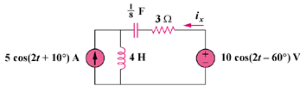

Figure 10.88
For Prob. 10.43.

Solution

Let , where is due to the voltage source and is due to the current source.

For , consider the circuit in Fig. (a).

(a)

j8

-j4

3

10-60 V
+

I₁

For , consider the circuit in Fig. (b).

510 A

(b)

j8

-j4

3

I₂

Therefore, 9.902 cos(2t – 129.17) A

